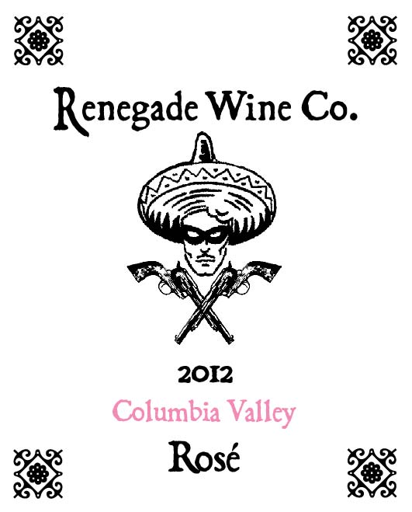

The Renegade Wine Co. is excited to release the newest vintage of our rose’, the 2012 Columbia Valley Rose’! 500 cases of this tasty summer sipper were produced. It was made from 76% Syrah, 20% Mouvedre, and 4% Cinsault. The grapes were pressed directly after harvesting, and the juice was drained to stainless steel tanks, where the wine was fermented at a cool temperature to retain the fresh fruit characters of the final product. It has wonderful aromas of fresh pomegrantes and citrus, some red berries, and even rhubarb. This wine will be the perfect pairing with a fresh beet salad and crumbled goat cheese, or grilled salmon on your deck, Go ahead, BE A RENEGADE!

